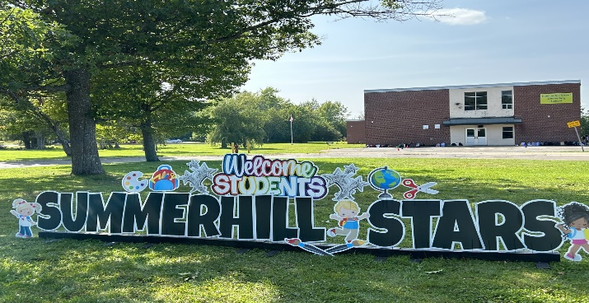
SEPTEMBER MEMO
Principal – Mrs. Shannon Atherton - shannon.atherton@nbed.nb.ca
Vice – Principal – Ms. Sheila Morgan – sheila.morgan@nbed.nb.ca
Administrative Assistant – Mrs. Crys Myrie – crys.myrie@nbed.nb.ca
We have had an excellent first few days at Summerhill! It has been a pleasure getting to know our new students and welcoming back our STARS who have attended in the past.
Unfortunately, I was unable to be at the Meet the Teacher night, so I am including a picture so you will know who I am if we meet this year. I hope to get a chance to see you all in person at some point throughout the year!
Some of this memo may be a repeat of information that you have received already, but I want to ensure all our families are receiving the communication coming home. Monthly memos from me will be sent out electronically only starting next month. If you would like to receive a paper copy as well, please fill out the section on the bottom and return it to school.
We believe in the 3 Stars at Summerhill - Be Respectful, Be Responsible and Be Safe as this is what guides us each day. We look forward to our students arriving each day ready to learn and to be the best students they can be. As a school community, we will work on teaching, modeling and reinforcing prosocial behaviour and include activities and events that reinforce kindness and caring and responsible citizenship.
One of our goals involves our Positive Working and Learning Environment so in addition to focusing on the 3 stars, we are also focusing on inclusivity and diversity. We want all our students to feel like they belong and will be working on strategies to help with this goal. As the school year progresses, we will be keeping you informed on our School Improvement goals.
We are also committed to improving the communication between home and school. Each student has a new blue binder that holds our Student Handbook. As well, there are communication pages inside for you to write notes or messages to your child’s teacher. This binder will go back and forth from home to school each day. Permission forms, notices and all correspondence will be in this binder!
We encourage you to get all forms returned as soon as possible. There is a $4.00 student fee which includes the price of the communication binder and plastic pouch.
Here is a list of staff members for the 2023-2024 school year:
^{GRADE 3 TEAM} ^{GRADE 4 TEAM}
MRS. CORDY (Grade ¾) – ROOM 131 ^{MS. MORGAN – ROOM 218}
^{MRS. LACKEY – ROOM 139} ^{MS. HARRISON – ROOM 205}
^{MS. RANDALL – ROOM 141} FI – MLLE REES –Grade 4/5 - ROOM 216
^{FI – MME CLERK – ROOM 129} ^{FI - MME AITCHISON – ROOM 215}
FI - MME ROWAN – HOWE – ROOM 130

^{GRADE 5 TEAM} School Counsellor/Resource (0.2) – Mrs. Voutour
MME MACCREADY – ROOM 207 (Intensive French Sept.– Feb) Resource Teachers – Ms. Thurrott and Ms. Jarema
MME ZELAZNY - ROOM 206 (Intensive French Sept.-Feb.) Behaviour Intervention Mentor – Mr. MacKay
^{FI - MLLE NEADOW - ROOM 210} ^{Music Teacher – Ms. Jarema}
Library Assistant – Mrs. Podonavitch
Physical Education – Mr. Smallman (until Christmas)/Mrs. Meek (starting in Jan. 2024)
**NEW POSITION – Melissa Morris – Academic Support Teacher for Reading and Numeracy

EDUCATIONAL ASSISTANTS: Mrs. Pomeroy, Mr. Tynes, Mr. Merlo, Mrs. Seeley, Mrs. Basque, Mrs. Sauve, Mrs. MacBeth, Mrs. Quigley

Our administrative assistant is Mrs. Myrie and she is your first point of contact when you call the school. We also have two amazing custodians – Ms. Amanda Fraser and Mr. Scott MacDonald.
Here are a few other important reminders for the start of the year:
- Student arrival for walkers and students getting dropped off starts at 8:05 (Please be mindful that we do not have a teacher on duty at the front until that time and the door is locked). All students walking or getting dropped off must come through the front door. Please do not drive through the bus zone or park in the staff parking lot.

- Our bell rings in the morning at 8:25 and our dismissal bell rings at 3:15. We dismiss our students walking first through the front door at 3:10 (a few minutes before the bell) and then our bus students will leave at the side door in the bus zone.

- This year, we will have one recess outside and one lunch time outside. All students will go outside in the morning upon arrival (except the first few earlier busses). The morning “snack” recess is from 10:30 – 10:50 and the lunch recess is from 12:45 – 1:05. Students will eat lunch from 12:25 – 12:45.

- More information about Hot Lunch will come out in a few weeks!

- Drop-off and Pick Up- If you will be driving your child to and from school each day, it is extremely important that you follow the designated drop off and pick up area traffic flow while keeping in mind it is 20 km/hour. Please enter the second driveway (not the bus loading zone or parking lot), and proceed to the front of the building (main office doors). Please do not block the walkway to the front doors. You can drop your child off at this location. In order to maintain a safe and orderly environment for our students, we ask that parents and caregivers who are picking up their children at dismissal please wait in the parking lot or in your vehicles. Our walkers and students getting picked up are leaving the building at approx. 3:10 p.m. and are coming out the front doors with others in their class.

If you are picking your child up during the school day, please remember to ring the bell and let Mrs. Myrie know who you are picking up. She will call your child down to meet you. Please do not use the bus loading zone for drop off or pick up. If you have any questions regarding drop off or pick up, please contact the administration and we would be happy to help you. We thank you for supporting us in keeping our building a safe and positive learning environment for all!

- We had many new volunteers sign up for Hot lunch, breakfast program, field trips, fundraising or PSSC. If you would like to help in any way, please email me at Shannon.atherton@nbed.nb.ca. We would love to include you in our special activities!

- NOTE: Our 2 Grade 5 English classes will be doing the Intensive French program this year starting in September until the end of January. This is a mandatory program for all Grade 5 students in N.B. Your child’s teacher will provide you with more information about the program and expectations. “Meet the Teacher” for Grade 5 Intensive French/English Prime classes (besides Grade 5 Frenchi Immersion) will be happening in a couple of weeks. We apologize for the delay.

- Please be mindful that changes can still occur to our class lists and we may have to move students to different classes.

- Please remember to pack water bottles for your child as we only have water filling stations here at school.

Physical Education - Our Phys. Ed. teacher, Mr. Smallman, loves to go outside and will take students outside often. Students need to be dressed for any kind of weather and have outdoor sneakers for Phys. Ed.

CALENDAR OF EVENTS
Sept. 22 | Positive Learning Environment Day – NO SCHOOL FOR STUDENTS
Sept. 29 | Terry Fox Walk – 10:50 – 11:30  Permission form will be sent home
Oct. 2 | National Day for Truth and Reconciliation Day – NO SCHOOL FOR STUDENTS
Oct. 9 | Thanksgiving Day – NO SCHOOL FOR STUDENTS
Oct. 12 | School Picture Day!  (Nov. 8 Retakes)
Oct. 13 | School Improvement Planning Day – NO SCHOOL FOR STUDENTS
Nov. 1 | Earth Rangers come to Summerhill for a Presentation from 2:00 – 3:00
Nov. 3 | Professional Learning Day – NO SCHOOL FOR STUDENTS
Nov. 13 | Remembrance Day – NO SCHOOL FOR STUDENTS
Nov. 24 | Professional Learning Day – NO SCHOOL FOR STUDENTS
Dec. 4 | Report Cards issued
Dec. 8 | Parent – Teacher Interviews/PL Day  No School for students
Dec. 22 | Last day of Classes for students (1/2 day for students)

***There was an incorrect date in the Student handbook (Dec. 2). Please correct with this newsletter as your guide.

PLEASE FILL THIS OUT ONLY IF YOU WANT A PAPER COPY OF THE MONTHLY NEWSLETTER:
YES! Please continue to send a paper copy of the school newsletter home with

__________________________________________________
CHILD’S NAME
_________________________________________________
HOMEROOM

