**Summerhill Street Elementary School - MARCH/APRIL 2024**

**Shannon Atherton – Principal Sheila Morgan – Vice-Principal**

**Crys Myrie – Administrative Assistant**



Follow the exciting learning opportunities on instagram at:

summerhillstars

SCHOOL IMPROVEMENT PLAN SCOREBOARD

When you are in the school, you will notice two scoreboards that describe the progress in our School Improvement Plan. The one located across from the library shows our Math progress. As you can see, students are improving in their skills in Number Sense and Place Value! We hope to reach our goal of 85% by the end of the year.

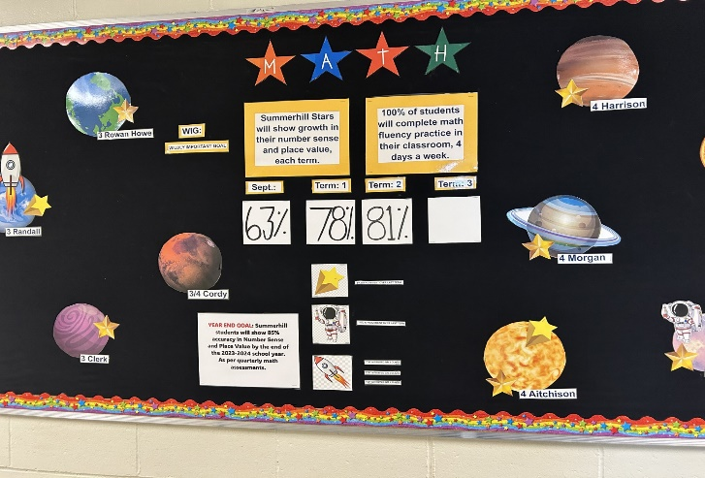

GOAL:

To target our intervention for students in all grades in Math based on ability to see improved results. Summerhill students will show growth in their number sense and place value each term. 100% of students will complete Math fluency practice in their classroom, 4 days a week.

This is our Positive Working and Learning Goal that is displayed beside the library. Our goal is as follows:

*Students will feel empowered with the knowledge and skills of how to actively contribute to maintaining a calm, safe, and happy school community. All Stars will strive to make our school a place where everyone is invited to feel a sense of belonging.*

*School staff is committed to fostering a school environment where every student feels valued, respected, and included. Classroom teachers will dedicate 10 mins daily to focus their efforts on conversations, teaching, modeling, and reinforcing pro-social behaviors that promote inclusion, diversity, and equity.*

Based on student surveys we have improved since the start of the year and our goal is to improve at least by 10% improvement in each category by the end of the year.

CALM +2% HAPPY +1%

SAFE +2% BELONGING +2%

INTERACTIONS WITH OTHERS AND MAKING IT RIGHT

During the month of February, we focused on lessons about Kindness. We had amazing lessons and leadership shown from our students in an assembly and students understand and know what is expected in terms of how we treat others. We do expect positive interactions with others to continue and we would like students to focus on treating people with respect and kindness every day.

**We are hoping you can speak to your child at home to encourage this as well.** It is not okay to lash out at others verbally or physically. Neither is it okay to “get revenge” or retaliate when someone is bothering you.

We do encourage students to report to adults if someone has made them feel uncomfortable or they see something that is not safe. Our staff works hard to follow through on incidents so that students recognize that if they come to an adult with an issue, the adult is helping to work and mediate with the students involved.

If there is fighting, disrespect, defiance or unsafe behaviour shown at school, follow through for this behaviour can include: restitution/making it right, doing a “Think/Reflection” sheet, missing recess, having to walk with an adult outside, phone calls home or could result in a suspension from school. Incidents are entered in PowerSchool with the details of what happened and how it was handled.

**In March, our focus will be on RESTITUTION or MAKING IT RIGHT and students will learn more about what that looks like, sounds like and feels like. We acknowledge that mistakes can happen and interactions may not always go the way they should, however, we do expect our STARS to make their actions right either with an apology or doing something kind for the person who was hurt. Kindness is everyone’s responsibility and that means that if an unkind act does happen, it is also our responsibility to make it right to the person to whom we have been unkind.**

**OROMOCTO RATIONALIZATION PROJECT – PUBLIC MEETING #2**

ASD-W and EECD had initiated a review of schools in the Oromocto Education Centre area to examine potential scenarios for long-term infrastructure planning. The review found five potential scenarios for updating school infrastructure in the area, based on population growth and student enrolment numbers. These infrastructure plans have now reached a point where they have been recorded on the Stable Departmental Infrastructure Priorities list, under the name Oromocto K-8 Rationalization. In order to take next steps in the process, ASD-W is required to conduct a sustainability study as outlined in provincial Policy 409- Multiyear School Infrastructure Planning. This site will contain all relevant documents for the study that will take place from January – May 2024.

**The next meeting is at our school on Saturday, March 16**

**Location:  Summerhill Street Elementary School**

* 1:00 PM – 3:30 PM              Gesner Street and Summerhill Street Elementary Schools’ Community Presentations in sequential order.
* The Summerhill PSSC will have a presentation for this meeting

**If you are interested in more information please visit the ASD-W website.**

The PSSC will have their next meeting at 6:30 pm on April 16th pm. All are welcome to attend. There is always great discussion on how we can be the BEST we can be at Summerhill!

PARENT – TEACHER INTERVIEWS/REPORT CARDS

**This term, report cards will be handed out on Thursday, April 11. Parent teacher interviews will be held on the afternoon of April 15 from 1:00 – 4:00 p.m. and the evening portion of interviews will be held on April 18 from 4:00 – 7:00 p.m.**

Enriching and Promoting Bilingualism Grant – MARCH 21

We have been given a grant to spend on Enriching and Promoting Bilingualism at our school. On Thursday, March 21, all students are able to attend a play at the Fredericton Playhouse on Queen Street.

A permission form will be coming home with the details. Thank you to Mme. Neadow who was able to access grants to have this exciting and educational trip paid for our students.

We are looking forward to this day!

**APRIL 8 – SOLAR ECLIPSE**

On April 8, 2024, a spectacular total solar eclipse will be visible in certain regions of the province, providing a unique opportunity for your children to witness this awe-inspiring natural phenomenon. It will occur over a 2-hour period. The timing is dependent on your location, but for New Brunswickers it will be approximately 3:30 – 5:30pm AST. To check for when the eclipse will happen for your location, please go to Timing of eclipse - [https://www.timeanddate.com/eclipse/map/2024-april-8](https://can01.safelinks.protection.outlook.com/?url=http%3A%2F%2Ftrack.spe.schoolmessenger.com%2Ff%2Fa%2FSZY6BcgKEC0kfuDz1RuW-g~~%2FAAAAAQA~%&data=05%7C02%7CShannon.Atherton%40NBED.NB.CA%7C2606507dba8049746e7808dc23669d8c%7C4d2b5fdfc4d24911870968cc2f465c9f%7C0%7C0%7C638424171302436942%7CUnknown%7CTWFpbGZsb3d8eyJWIjoiMC4wLjAwMDAiLCJQIjoiV2luMzIiLCJBTiI6Ik1haWwiLCJXVCI6Mn0%3D%7C0%7C%7C%7C&sdata=Pp%2BUnIzLwXmbPc0bhbBLRCkTrJ0A76BEOPoKfi3SoNI%3D&reserved=0)  and put in your location.

**Please note that all schools in ASD-W will dismiss 3 hours early on April 8th, to allow students to safely arrive at their after-school destinations before the eclipse begins.  Schools may send messaging specific to their scenario as we approach the date.  There will be no extra-curricular activities after school on this date.**

**It is crucial to ensure that your children view the eclipse safely to protect their eyes from harm**. **NEVER LOOK DIRECTLY AT THE SUN** without proper solar viewers! Please review some essential guidelines attached.

**WE’RE STILL COLLECTING!**

We are still collecting pop tabs for Muscular Dystrophy so please keep sending them in.   It is great to see our families helping to support such a worthwhile cause.

**ELECTRONIC DEVICES/TOYS BROUGHT TO SCHOOL**

**In our Student Handbook under “General School Rules”, there is a section about toys and electronics. “Toys, cards or electronics are not the responsibility of the school. We appreciate children not bringing any items to school that are valuable to them.” Also, CELL PHONES are not permitted at school. If students need to contact home, they can use the phone at school. If your child is bringing a cell phone to school, it is not to be used during the instructional day.**

**SCHOLASTIC BOOK FAIR**

We will host another Scholastic Book Fair in April to coincide with Parent – teacher interviews. This will be held between April 10 – 18.

|  |  |
| --- | --- |
| **DATES TO REMEMBER: Mark Your Calendar** | |
| Mar 17 | Happy St. Patrick’s Day |
| Mar 21 | Enriching and Promoting Bilingualism Trip to the Playhouse! 10:00 – 11:00 |
| Mar 22 | Yearbook Order forms due |
| Mar 25 | NO SCHOOL FOR STUDENTS |
| Mar 29 | GOOD FRIDAY |
| April 1 | EASTER MONDAY |
| April 3 | Geordie Theatre presents, “Perfect Storm” in our gymnasium |
| April 8 | Solar Eclipse (students will be dismissed 3 hours earlier) |
| April 10 – 18 | Scholastic Book Fair |
| April 11 | Report Cards Issued |
| April 15 | PL day/Parent-teacher Interviews in p.m. (1:00 – 4:00) – NO SCHOOL FOR STUDENTS |
| April 18 | Evening Parent Teacher Interviews - 4:00 – 7:00 p.m. |
| May 3 | NO SCHOOL FOR STUDENTS – NBTA Council Day |
| May 13 | NO SCHOOL FOR STUDENTS – NBTA Branch Meeting Day |
| May 13-28 | GRADE 4 PROVINCIAL ASSESSMENT FOR READING AND SCIENCE |
| May 13-28 | GRADE 5 PROVINCIAL ASSESSMENT FOR MATH AND FI READING |
| May 20 | NO SCHOOL FOR STUDENTS – Victoria Day |
| June 25 | Last day of school for students  Final Report Cards issued |